|  |  |
| --- | --- |
| http://paperpkblog.com/admissions/wp-content/uploads/2015/05/Jobs-in-Foundation-University-Islamabad-FUI-20141.jpg | **FOUNDATION UNIVERSITY ISLAMABAD** |

**Intelligent Energy Scenario Analysis   
(IESA) Report**

***Submitted by***

FA21/BSSE/136 – Muhammad Farzam Baig

FA21/BSSE/138 – Muhammad Suffian Tafoor

FA21/BSSE/139 – Muhammad Yasir Khan

**BACHELORS**

**IN**

**COMPUTER SOFTWARE ENGINEERING**

**YEAR**

**2021-2025**

***Project Advisor***

ADVISOR NAME Dr Muhammad Shaheen

COORDINATOR NAME Dr Sajid Ali Khan

Submitted to the Department of Software Engineering of Foundation University Islamabad, in partial fulfilment for the requirements of a Bachelor of Computer Degree in Software Engineering

**DEDICATION**

Any dedication should be given here. Paragraph Justified.

**ACKNOWLEDGEMENTS**

All acknowledgements are here in justified paragraph.

**STATEMENT OF ORIGINALITY**

We namely **Muhammad Farzam Baig, Muhammad Suffian Tafoor and Muhammad Yasir Khan, s**ubmitting thesis titled “**Intelligent Energy Scenario Analysis**”. State that we clearly understand what plagiarism is and we have also read about it using online sources. As such, we claim that this entire work (code, reports etc.) is our own effort. We have not used/copy or pasted or paraphrased even a single line of code or sentence from any other source without giving a proper reference to it. Based on our confidence in our originality, we allow the University to run anti-plagiarism software on the same.

We understand that if now, or in the future, ever it is found out that we have not been honest and have plagiarized, the university will take action and will result in disciplinary action, such as the cancellation of our degree and we can be liable for any subsequent punishments as deemed appropriate by the University as well as the Higher Education Commission Pakistan.

[Signature and date]

Muhammad Farzam Baig

[Signature and date]

Muhammad Suffian Tafoor

[Signature and date]

Muhammad Yasir Khan

**COPYRIGHT STATEMENT**

Copyright in text of this report rests with the student authors. Copies (by any process) either in full, or of extracts, may be made only in accordance with instructions given by the author. Details may be obtained by the Librarian. This page must form part of any such copies made. Further copies (by any process) of copies made in accordance with such instructions may not be made without the permission (in writing) of the author.

The ownership of any intellectual property rights which may be described in this project is vested in FUI, subject to any prior agreement to the contrary, and may not be made available for use by third parties without the written permission of the FUI, which will prescribe the terms and conditions of any such agreement.

**CERTIFICATE OF APPROVAL**

It is certified that Project titled **“IESA”,** presented on __17 Dec,2024___, has been duly approved by the evaluation committee.

|  |  |
| --- | --- |
| **Project Advisor:** | __________________  Dr Muhammad Shaheen Khan |
| **Project Coordinator:** | __________________  Dr Sajid Ali Khan |
| **Manager Graduate Off:** | __________________  Dr Arif Jamal |

z

**ABSTRACT**

The Intelligent Energy Scenario Analysis (IESA) system is an AI-driven software solution designed to analyse, forecast, and optimize energy Related scenarios. The system focuses on both gas and electricity usage, enabling energy planners, IT administrators, and data operators to make informed decisions. IESA integrates historical data visualization, predictive modelling, and scenario-based analysis to address the increasing demand for energy efficiency and sustainable practices. Using advanced algorithms such as WisRule for cognitive association and Linear Regression predictive insights, the system allows users to evaluate multiple energy scenarios by adjusting variables like production capacity, imports, and consumption trends. The results are presented in user-friendly dashboards, enabling clear and actionable insights.

The project concludes that IESA is a DSS (Decision Support system), that provides a scalable and cost-effective solution for energy management, with significant potential for applications at regional and national levels. Findings include precise energy consumption predictions, and tailored recommendations for energy savings. The ability to evaluate multiple scenarios and compare outcomes allows decision-makers to select optimal strategies for energy resource planning.

**TABLE OF CONTENTS**

Chapter 1: Introduction 12

**1**.1 Introduction 12

1.2 Existing System 12

1.3 Literature Review 13

1.4 Problem Definition 14

1.5 Context Diagram 14

1.6 User Needs 14

Chapter 2: Introduction to Proposed System 16

2.1. Introduction 16

2.2. Project Background or Overview 16

2.3. Problem Description 16

2.4. Project Objectives 17

2.5. Scope 17

2.6. Project Features 18

2.7. Context Diagram 19

Chapter 3: Requirements Specification 20

3.1. Introduction 20

3.2. Functional Requirements 20

3.3. Flow model 20

3.4. Graphical User Interface 22

3.5. Data Model (ERD) 25

3.6. Non-Functional Requirements 26

**LIST OF TABLES**

Table 1.1: Existing Systems and Features 13

Table 2.2 Table for Features of IESA 19

Table 3.3: Functional Requirements for IESA 21

Table 3.4: Non-Functional Requirements for IESA 24

**LIST OF ILLUSTRATIONS**

Figure 1.1: DFD level 0 14

Figure 2.1: DFD level 0 19

Figure 3.1: Flow Model Diagram 21

**LIST OF ABBREVIATIONS**

|  |  |
| --- | --- |
| **Word** | **Phrase Definition / Abbreviation** |
| IESA | Intelligent Energy scenario Analysis |
| SRS | Software Requirements Specification |
| FR | Functional Requirement |
| NFR | Non-Functional Requirement |
| AI | Artificial Intelligence |
| IESA | Intelligent Energy Scenario Analysis |
| DSS | Decision Support System |
| DFD | Data Flow Diagram |

Chapter 1

# Introduction

* 1. **Introduction**

The report provides a complete overview of the Intelligent Energy Scenario Analysis (IESA) system, a cutting-edge tool which is designed to support energy related decisions and promote sustainability. We’ve developed it as part of the Bachelor of Software Engineering program at Foundation University Islamabad, this document details the methodologies, implementations, and necessary outcomes associated with IESA.

In this era, where energy resources are under unprecedented and unpredictable pressure to meet high demands, providing accurate and concise predictions and actionable insights is essential for effective decision-support system. The IESA system enables users with deep analytical insights into valuable energy usage scenarios, enabling the development of strategies for sustainable energy management and cost optimization. By leveraging advanced algorithms such as WisRule, Linear Regression, and K-means Clustering, the system predicts future energy needs and facilitates the adoption of best practices for energy efficiency and sustainability.

* 1. **Existing System**

Existing energy management systems face several issues that hinder and limitize their efficiency and scalability. Most traditional systems lack advanced predictive capabilities and scenario analysis features, providing only basic data visualization and analysis tools. Also, many of these systems are expensive, require alot of training, and fail to accommodate diverse stakeholder requirements, such as IT administrators, energy planners, and data operators.

For instance, tools like EnergyPLAN and HOMER primarily focus on high-level energy system analysis but lack in terms of AI-driven algorithms for micro level forecasting and optimization. Furthermore, existing systems often overlook personalization and user-friendly interfaces, which limits their adaptability and flexibility for varying user expertise levels. These shortcomings highlight the need for a new and versatile, AI-driven platform like IESA to address these gaps.

Table 1.1: Existing Systems and Features

|  |  |  |  |  |  |  |  |  |  |
| --- | --- | --- | --- | --- | --- | --- | --- | --- | --- |
| **Features** | **LoadSEER** | **EnergyPLAN** | **HOMER Pro** | **PLEXOS** | **OSET** | **LEAP** | **ETAP** | **Siemens PSS/E** | **Our System** |
| **Historical Data Visualization** | ✗ | ✓ | ✓ | ✓ | ✗ | ✓ | ✓ | ✓ | ✓ |
| **Prediction Modeling** | ✓ | ✓ | ✓ | ✓ | ✓ | ✓ | ✓ | ✓ | ✓ |
| **Scenario Analysis** | ✓ | ✓ | ✓ | ✓ | ✓ | ✓ | ✓ | ✓ | ✓ |
| **Recommendations and Insights** | ✗ | ✗ | ✗ | ✓ | ✗ | ✗ | ✗ | ✓ | ✓ |
| **Data Visualization in Dashboards** | ✗ | ✗ | ✓ | ✗ | ✗ | ✗ | ✓ | ✗ | ✓ |
| **Exportable Reports** | ✗ | ✗ | ✓ | ✓ | ✗ | ✗ | ✓ | ✓ | ✓ |
| **Comparison among Scenarios** | ✓ | ✗ | ✓ | ✓ | ✓ | ✗ | ✓ | ✓ | ✓ |

* 1. **Literature Review**

Numerous studies have highlighted the importance of integrating AI and machine learning in energy management systems. Researches have shown that algorithms like Linear Regression and K-means Clustering are effective in predicting energy consumption trends and identifying patterns in large datasets. Similarly, WisRule algorithm has demonstrated superior performance in extracting meaningful insights from complex energy scenarios, making it a preferred choice for scenario-based analysis since it has four parameters.

Existing systems such as EnergyPLAN and PLEXOS have been widely adopted for energy modeling and planning. However, these tools often lack dynamic forecasting capabilities and require significant domain expertise for effective use. Studies also emphasize and highlight the need for user-friendly dashboards and scenario analysis to bridge the gap between technical complexity and actionable insights. The IESA system addresses these gaps by adding state-of-the-art algorithms with intuitive visualization tools to support stakeholders in achieving sustainable energy practices.

//add a table to explain here

* 1. **Problem Definition**

The world is facing critical energy related crisis, with resources congested to meet the growing demands of industries and households. Existing energy management solutions often fall short in providing accurate, actionable insights and dynamic forecasting capabilities. These systems are either too complex, costly, or very narrowly focused, leaving energy planners and decision-makers without proper tools to optimize energy consumption and promote sustainability.

The Intelligent Energy Scenario Analysis (IESA) system addresses this problem by combining advanced AI algorithms with user-friendly interfaces to provide complete energy management systems. The system's ability to simulate multiple energy usage scenarios, predict future consumption trends, and offer actionable recommendations empowers users to make informed decisions, ensuring energy efficiency and sustainability at both micro and macro levels.

* 1. **Context Diagram**

Figure 1.1: DFD level 0

* 1. **User Needs**

The Intelligent Energy Scenario Analysis (IESA) system is designed to counter the diverse needs of its primary users, which include IT administrators, energy planners, and data operators.

* Comprehensive Data Analysis: Users need the ability to analyse historical energy data and forecast future consumption trends to make informed decisions.
* Scenario Evaluation: Energy planners require tools to create, simulate, and compare multiple energy usage scenarios, considering variables like production capacity, imports, and yearly consumption patterns.
* Personalized Dashboards: IT administrators and data operators need customizable dashboards to visualize data and insights in formats that suit their roles and preferences.
* Predictive Insights: Users require predictive modelling capabilities to anticipate future energy demands and optimize resource allocation.
* Sustainability Metrics: Stakeholders need tools to calculate carbon footprints and receive actionable recommendations to promote sustainable energy practices.
* Ease of Use: The system must feature an intuitive interface that accommodates users with changing levels of technical expertise, ensuring accessibility and efficiency.
* Real-Time Updates: Users need timely updates and alerts about energy trends, anomalies, or savings opportunities to respond quickly to emerging situations.
* Data Security: All user data must be securely managed, ensuring compliance with privacy standards and protecting sensitive information.

Chapter 2

# Introduction to Proposed System

* 1. **Introduction**

The proposed system, Intelligent Energy Scenario Analysis (IESA), addresses the need for an advanced decision support system to optimize energy efficiency. The energy sector requires innovative approaches to ensure efficiency, reduce cost, and encourage best environmentally friendly practices. However, existing systems lack the capacity to provide detailed predictions and actionable insights based on historical energy data.

The Intelligent Energy Scenario Analysis (IESA) is designed to empower users to take advantage of detailed predictions and actionable insights to take the best decisions. It employs

Linear regression, WisRule, the World’s first cognitive algorithm for wise association rule mining, etc. and offer personalized recommendations and visualize trends. IESA stands as a pivotal tool in promoting sustainable energy practices on a national scale.

* 1. **Project Background or Overview**

Intelligent Energy Scenario Analysis (IESA) is an AI based business intelligence project that will revolutionize energy scenario analysis by utilizing WisRule**,** Linear regression, K Means Clustering etc. This would help in understanding different demand profiles, identifying inefficiencies, and targeting energy-saving interventions more effectively. IESA aims to predict future scenarios related to energy, such as gas and electricity production and consumption, as well as associations between energy import, generation, and production etc. IESA provides users with comprehensive business intelligence on total energy management, IESA is a DSS (Decision Support System) that enables optimal decision-making for sustainability and cost efficiency. The project will analyse historical energy data to predict future needs and offer personalized recommendations, helping users to make better future decisions

* 1. **Problem Description**

The increasing demand combined with inefficacies in its usage planning poses a significant challenge in terms of sustainability, resource management, and cost management.

Traditional methods and Existing Decision Support systems for energy planning and forecasting fail to account for complex variables and lack accurate forecasting and actionable insights for energy savings. These systems are quite expensive in terms of their licensing and are complex, making it difficult to learn about them. They are also unable to provide dynamic predictions and personalized recommendations. This leads to inefficient resource allocations, increased costs, and limited environmental benefits.

There is a need for an intelligent solution that provides accurate cost-effective and user-friendly solutions and IESA addresses these problems with personalized recommendations, and actionable insights, enabling users to optimize energy usage that supports the data-driven decisions.

* 1. **Project Objectives**

The Intelligent Energy Scenario Analysis (IESA) is a sophisticated business intelligence project designed to enable users to optimize gas and electricity usage. By helping to reduce energy wastage, lower costs, and contribute to a greener future on a national scale, IESA offers an impactful solution for sustainable energy management. The software utilizes historical data and employs the WisRule algorithm to analyze and visualize patterns of energy production and consumption-related scenarios, providing predictive insights. At the same time, K-Means Clustering will be used for grouping data based on similar consumption patterns, and Linear Regression will be used for forecasting energy usage and predicting future energy trends. IESA aims to predict future energy-related scenarios, such as gas and electricity production and consumption, as well as associations between energy import, generation, and production etc.

* 1. **Scope**

The Intelligent Energy Scenario Analysis (IESA) provides a comprehensive decision support system for energy management by providing detailed predictive analytics, and scenario-based insights, forecasting and optimization of different energy scenarios such as energy consumption and production.

As an advanced system, IESA captures historical consumption data, stores it, and makes it accessible for visualization and scenario analysis. Allows users to explore predictive trends, receive personalized recommendations for optimizing energy usage, and compare predictions using various algorithms. The System also promotes sustainability by offering actionable insights, helping organizations minimize energy wastage, reduce costs, and support eco-friendly practices.

* 1. **Project Features**

Table 2.2 Table for Features of IESA

|  |  |  |
| --- | --- | --- |
| ID | Feature | Description |
| FT01 | Energy Data Acquisition | This feature interacts with user to get input data from user through csv/xml. |
| FT02 | Energy Data Storage | This units extracts data from csv/xml inputted by user and stores in Database. |
| FT03 | ETL | This Module extracts data from database transforms it and loads into our system. |
| FT04 | Scenario Analysis | The system must analyze historical data and generate patterns for production and consumption, as well as associations between energy import, generation, and production etc. |
| FT05 | Prediction Engine | The system must use WisRule, Linear Regression, K Means Clustering for prediction based on different scenarios |
| FT06 | Data Visualization | The system must visualize both historical data and predicted data on dashboard using graphs and charts. |
| FT07 | Reporting | The system must allow to share and print reports both in hard and soft form. |
| FT08 | Personalized Recommendations | The system must provide user with recommendations for future decision based on historical and predicted data. |

* 1. **Context Diagram**

Figure 2.1: DFD level 0

Chapter 3

# Requirements Specification

2. 1. **Introduction**

This chapter refers to the requirement and specifications of IESA. Specifications include Functional Requirements, Quality Attributes, and Non-Functional Requirements of IESA. The purpose of this chapter is to give a deep understanding of the requirements, specification and functionality of product.

* 1. **Functional Requirements**

Table 3.3: Functional Requirements for IESA

|  |  |  |
| --- | --- | --- |
| ID | Description | Feature |
| FR01 | The system shall allow user to input historical data in form of csv/xml. | FT01 |
| FR02 | The System shall store input data in database. | FT02 |
| FR03 | The System shall extract data from database clean it and prepare it and load it into system | FT03 |
| FR04 | The system shall analyze historical data and generate patterns for different energy scenarios. | FT04 |
| FR05 | The system shall use WisRule, K mean cluster, Linear Regression and other algorithms to predict future energy related scenarios. | FT05 |
| FR06 | The system shall visualize both historical data, different scenarios and predicted data on dashboard using graphs and charts. | FT06 |
| FR07 | The system shall allow to share and print reports both in hard and soft form. | FT07 |
| FR08 | The system shall provide user with recommendations for future decision based on historical and predicted data. | FT08 |

* 1. **Flow model**

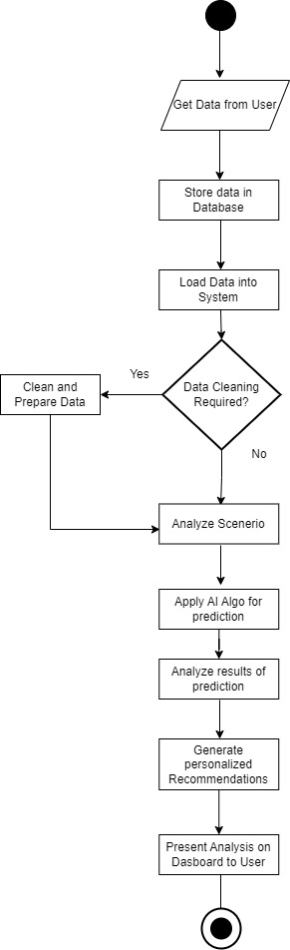

Figure 3.1: Flow Model Diagram

* 1. **Graphical User Interface**
* 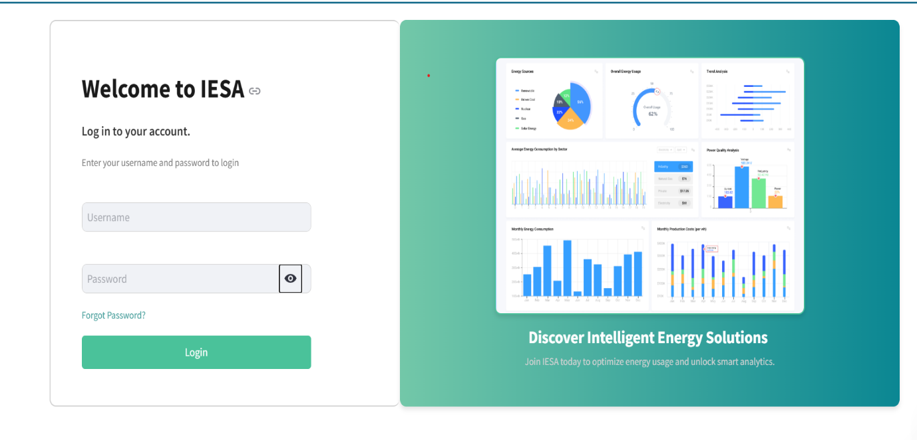Login Page
* Main Dashboard:

* A screenshot of a computer

  Description automatically generatedPowerBi Dashboard:

* 1. **Data Model (ERD)**

* 1. **Non-Functional Requirements**

The following table highlights Non-Functional Requirements for IESA:

Table 3.4: Non-Functional Requirements for IESA

|  |  |  |
| --- | --- | --- |
| ID | NFR | Statement |
| NFR01 | Response Time | The system should generate energy scenario report with in 15 seconds after user input’s data. |
| NFR02 | Performance | The system should be able to handle up to 10 parallel user without and performance degradation. |
| NFR03 | Availability | The system should be available for user’s 24/7 |
| NFR04 | Ease of use | Thes system should allow user to perform most of the functionality within 5 minutes of first use |
| NFR05 | Maintainability | The system should be modular and well documented with easily updateable and maintainable components |